 | CHAROTAR UNIVERSITY OF SCIENCE & TECHNOLOGY  DEVANG PATEL INSTITUTE OF ADVANCE TECHNOLOGY AND RESEARCH | 

Weekly Report
In this report students require to mention the work has been done during the week and planning for the next week. (Please fill individual report for each week)

Student ID: 18dce057 | Student Name: Shraddha Mehta
From Date: 20/04/2020 | To Date:28/04/2020
Semester: 4 | Internship ID: 30

Work done in last week (Attach supporting Documents):

- started working with android studio

- made my application logo

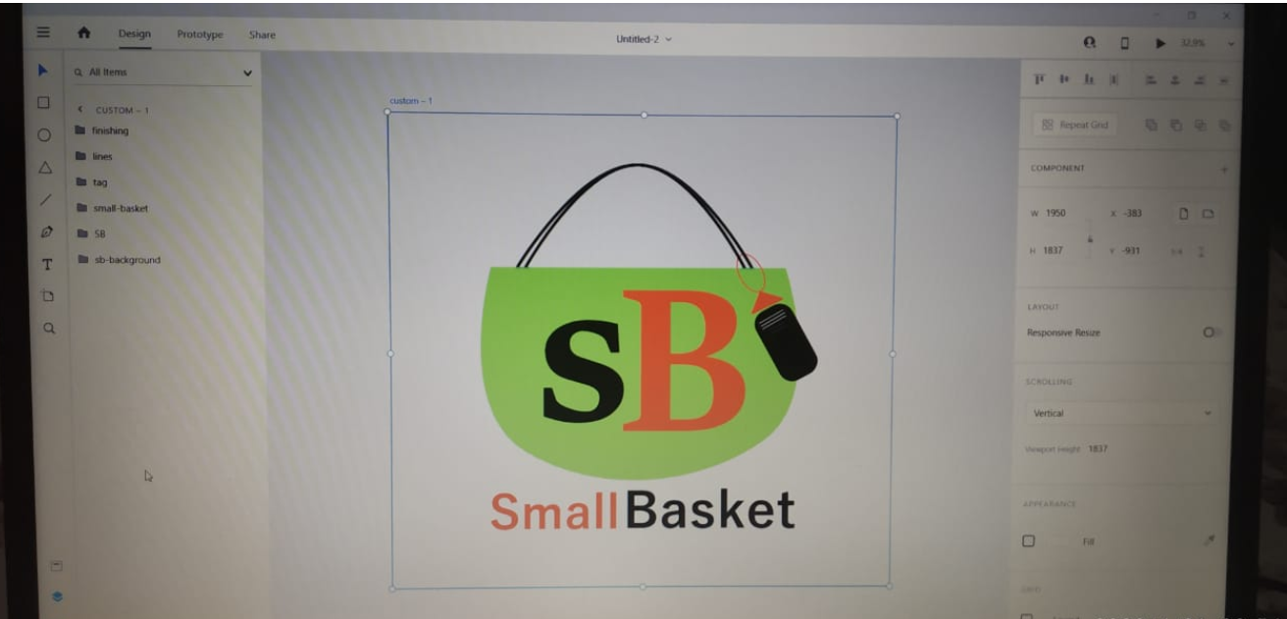

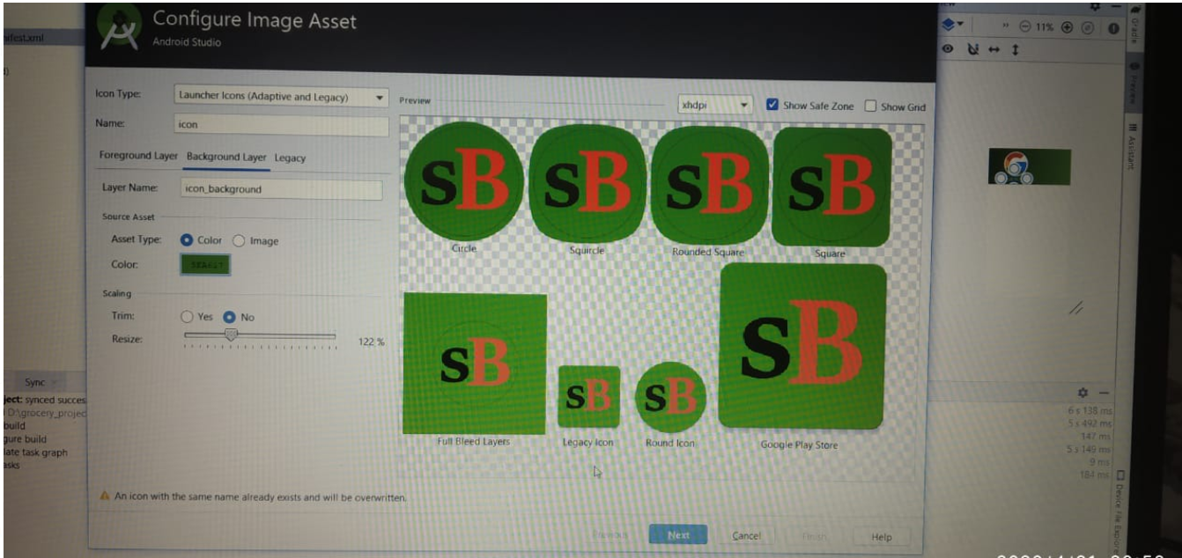

- Get Knowledge about various components of android Studio

There are some major components of Android Studio

- Activities : They dictate the UI and handle the user interaction to the smart phone screen.

2. Services : They handle background processing associated with an application.

3. Broadcast Receivers : A Broadcast is used to respond to the messages from other applications or from the System

- Content Providers : They handle data and database management issues.

- Android Mainfest : It is a XML file which is the root of the project source set.

- Res or Resource folder : It consist of the various resources that are used in the app

4. I have Made main Activity

Which is consist of two button if user doesn’t have an account then he or she will go for a join now button which will lead to register activity.
If user already has an account then he or she will go for second option it will lead to log in activity

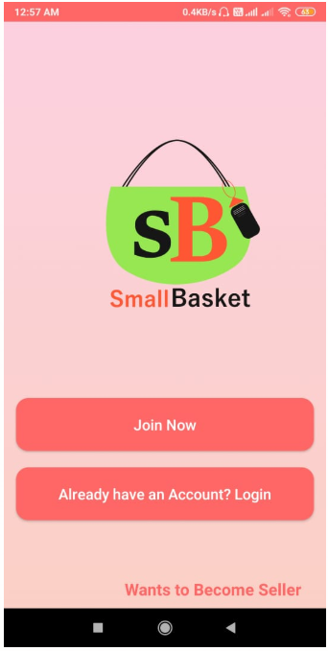

5. I have made Register Activity

If user doesn’t have an account then with help of register activity user can create his or her account. To create an account in small basket application user has to give some details like name , Phone number and need to create password..

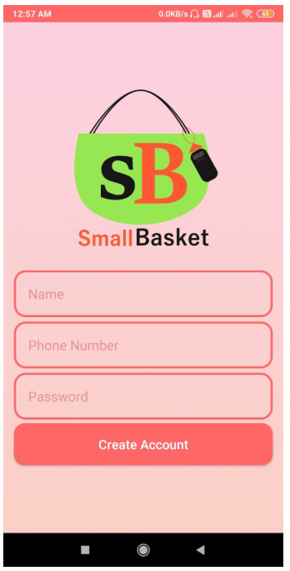

- Worked with firebase database

With help of firebase database phone number and password verify at log in time if it will coreect then user can log in otherwise not .

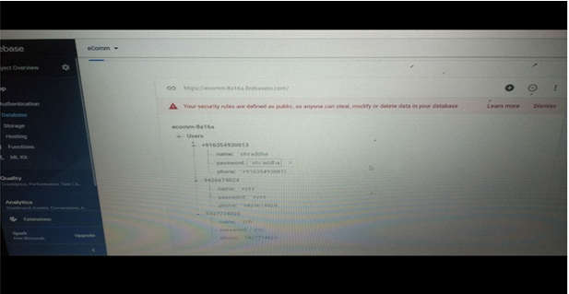

- I have made Log in Activity

If user or an admin who already have an account then with help of log in activity user can log in to my application.
I have also provided feature of forgot password to recover password with help of some security questions.
I have also provided check box if user or admin click and then log in then if they will close the application and again open at that time they don’t need to log in again.

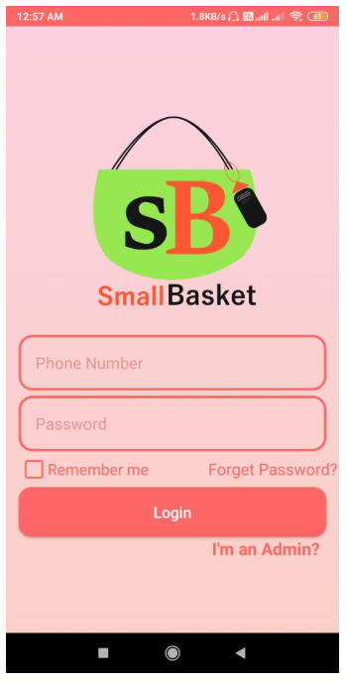

Plans for next week:

1. I will acquire more knowledge about firebase.
2. I will work on layout and designing.
3. I will obtain more about side navigation menu
4. I will construct cart Activity where user can see their orders.
5. I will build-up home activity with side navigation menu which will have options like cart, search, settings etc…

References:

https://developer.android.com/guide/components/fundamentals

https://developer.android.com/training/basics/firstapp

https://www.geeksforgeeks.org/android-app-development-fundamentals-for-beginners/

https://www.androidauthority.com/android-app-development-1128595/

https://www.androidhive.info/2016/10/android-working-with-firebase-realtime-database/

https://firebase.google.com/docs/database/android/start

Signature of External Supervisor Signature of Internal Supervisor

